Mechanics of Flexible Structures and Soft Robotics Homework 3
Luke Sage
Task 1: Description of Method:
We are given a beam in bending, constrained on the left side with a pin joint, and have control of the Dirichlet end conditions x, y and Θfor the right side of the beam with a robotic manipulator [1]. We are tasked with controlling the right side of the beam such that the center of the beam, x_star and y_star follow a given trajectory.

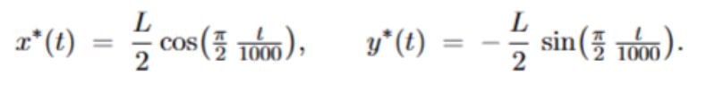

To achieve this outcome with a discretized beam structure, there are a number of methods. However, it is notable that the time period over which this task is to be achieved is quite long, indicating the inertial effects of the beam are relatively small. For the scope of this problem then, it is assumed that a steady state solver based solution is sufficient to track the required positions of x_star and y_star. If x_star and y_star were moved much quicker, it would be necessary to account for the inertial effect of each element at every step in time to devise a proper control scheme.
A function “GetDirichlet” is used to obtain desired values for the Dirichlet end conditions. GetDirichlet calls a static solver function based on the existing solver “objfun”. This static solver function, given guess Dirichlet boundary conditions, is able to find the steady state values of x_star and y_star. Each of the Dirichlet inputs (x, y and Θ) are perturbed, and a Jacobian Matrix is assembled

The Moore-Penrose pseudoinverse of the jacobian matrix is calculated. This has a useful effect: Since there are 3 inputs (x, y, Θ) and 2 outputs (x_star and y_star), there are infinite solutions. The pseudoinverse allows for the solution with the smallest possible change in input parameters. [1] This also enforces mostly smooth transitions for the Dirichlet boundary condition values. From the pseudoinverse, we have a linear approximation of the system that we can use for the Newton Raphson Method, which will iteratively converge on the solution of Dirichlet boundary conditions.

Pseudocode:
Note: X, Y and Θ are the Dirichlet boundary conditions, x_star and y_star are the positions of the center node.

Initialize setup variables
- Beam radii, length, discrete node count, Young’s Modulus, etc.
- Time step information (1000 sec, dt = 2 sec)
- Establish beam initial condition, weights
- Initialize storage variables for Dirichlet boundary conditions
- Generate trajectory x and y matrices for plotting

Main Loop:
- Iterate from t=0 to t=1000s in increments of 2 seconds (ii – time stepping)
- Calculate desired x_star and y_star positions based on trajectory and current time
- Call function GetDirichlet with desired x_star, y_star, and beam position guess from last step.

GetDirichlet (iv – path planning)
- Get tolerance value
- Establish perturbation values
- Loop: while error is smaller than tolerance
  - Set the Dirichlet boundary contidions from the guess x, y, and Θ
  - Evaluate staticSolver for guess Dirichlet boundary conditions.

StaticSolver
- Given guess Dirichlet boundary conditions, run Newton Raphson method solver:
- While error > tolerance, generate elastic stretching and bending force and Jacobian matrices. (Call getFS, getFb) This is a static solver, so there are no inertial or viscous forces.
- Linearly solve for the minimum energy condition of the free nodes, and update new node positions.
- Return new node positions

GetDirichlet (continued)
- Calculate the residual between the desired x_star, y_star
- For eachboundary conditions X, Y and Θ,
  - Perturb the position of the Dirichlet boundary conditions
  - Run staticSolver with perturbed boundary conditions
  - Derive slope of x_star and y_star over boundary condition.
- Assemble slopes into a 2x3 Jacobian. This matrix gives tells us locally how much change occurs in the x_star and y_star for any change in X, Y and Θ.
- Calculate the Moore Penbrose Pseudoinverse of the Jacobian Matrix. This method finds the solution (of infinite solutions) that minimizes X, Y, and Θ movement between steps.
- Calculate B, or the approximate linear change of Dirichlet BCs needed to create the desired x_star and y_star.
- Calculate a new residual and if the residual is smaller than the tolerance, return Dirichlet BCs X, Y and Θ. Otherwise, use new BCs as guess for next Newton Raphson method iteration.

Main Loop (continued)
- Set the boundary conditions of the main simulation to the output of GetDirichlet. (iii -- Enforcement of Dirichlet constraints)
  - Set x position of node n to X
  - Set y position of node n to Y
  - Set x position of node n-1 to X – ΔL × cos(Θ)
  - Set x position of node n-1 to Y – ΔL × sin(Θ)

- Call objfun with inputs of old beam position, new boundary conditions.

ObjFun (i – force/energy evaluations)
- Create a copy of the solution to the last step
- While error is smaller than tolerance
- Calculate force of inertia, Jacobian of inertia
- Calculate spring bending, stretching force and Jacobian
  - For each node, calculate gradient and hessian of energy
- Solve for position of the beam in the minimum energy condition.
- If error > tolerance, use new beam position as guess for next iteration

Main Loop (continued)
- Output of ObjFun is the new node positions.
- Calculate new velocity based on updated positions
- Store X, Y, Θof this time step to plot later
- Copy X, Y, Θ, pass them to next time step
- Copy beam position and velocity, pass them to next step
- Plotting
  - If the timestep is an plotting interval, output a plot of the beam with the trajectory shown.

Plot the X, Y and Θ positions of the Dirichlet constraints over time.
Task 2: Plot of Control Inputs Over Time:
Figures [1-3] show the Dirichlet Constraints over time. The pseudoinverse solver allows the constraint change to be smooth over time, which is seen in these plots.
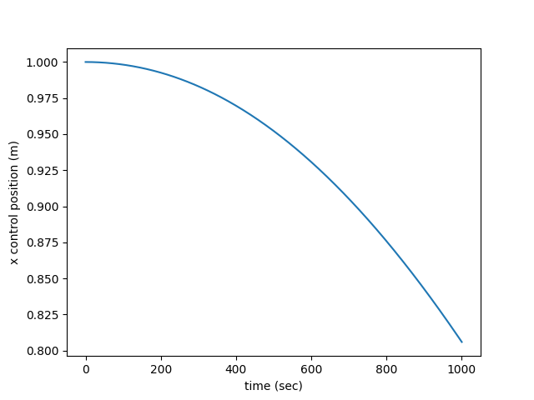
Figure 1. X Dirichlet Constraint over time

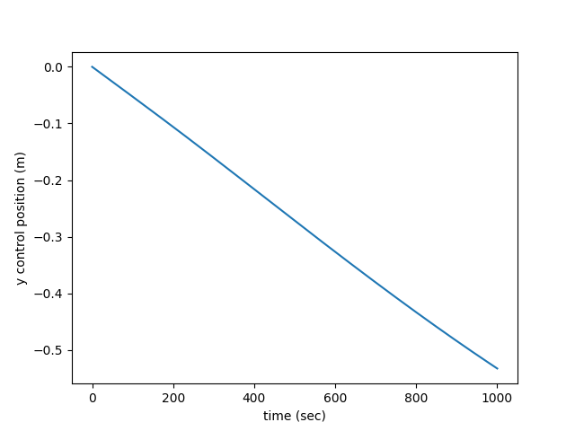
Figure 2. Y Dirichlet Constraint over time

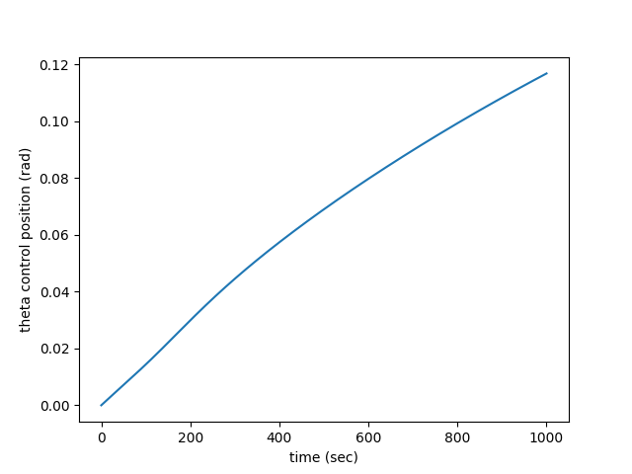
Figure 3. Θ Dirichlet Constraint over time

Task 3: Snapshots of Beam Shape During Motion:
Figures [4-9] show the positions of the beam over time. The black line and nodes represent the bending beam. The red curve shows the trajectory the beam should follow, and the red dot is the desired control location of the center of the beam. These plots show a very close match between the center of the beam and the trajectory. If the desired position moved quicker, it is likely inertial forces would come into play and require a more complex solution. However, at these low speeds, the method proposed in this homework is very effective.

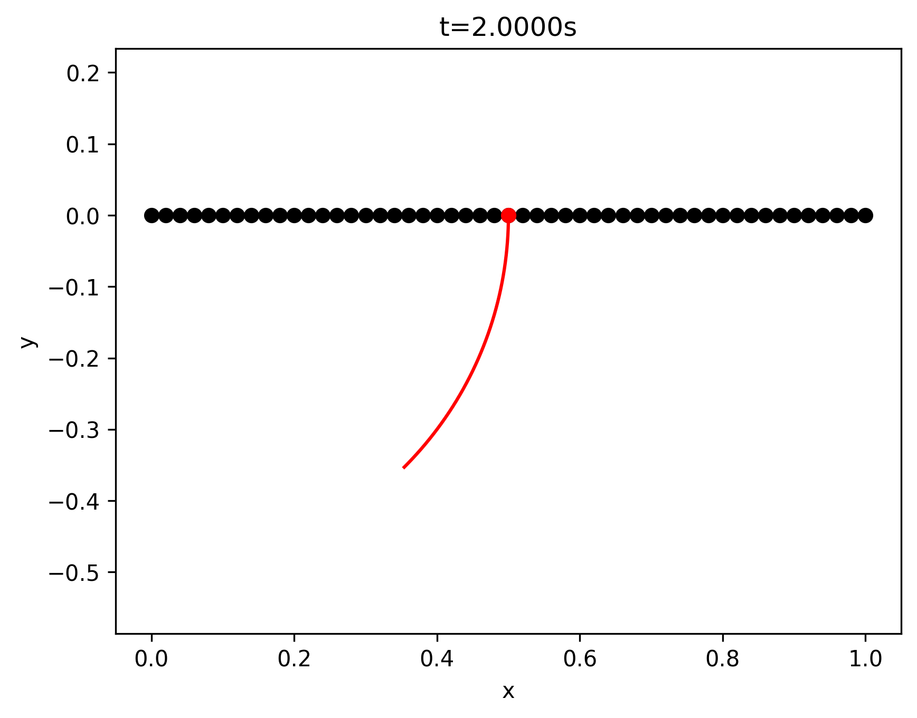

Figure 4. Beam at 2 sec

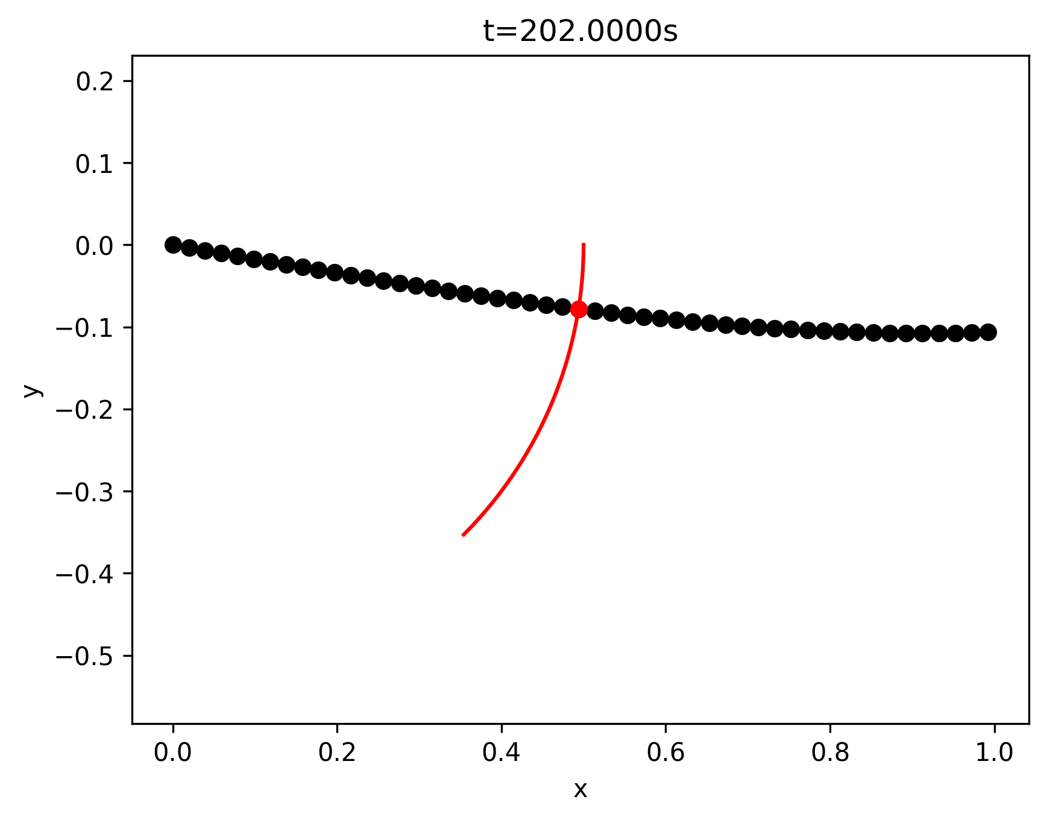
Figure 5. Beam at 202 sec

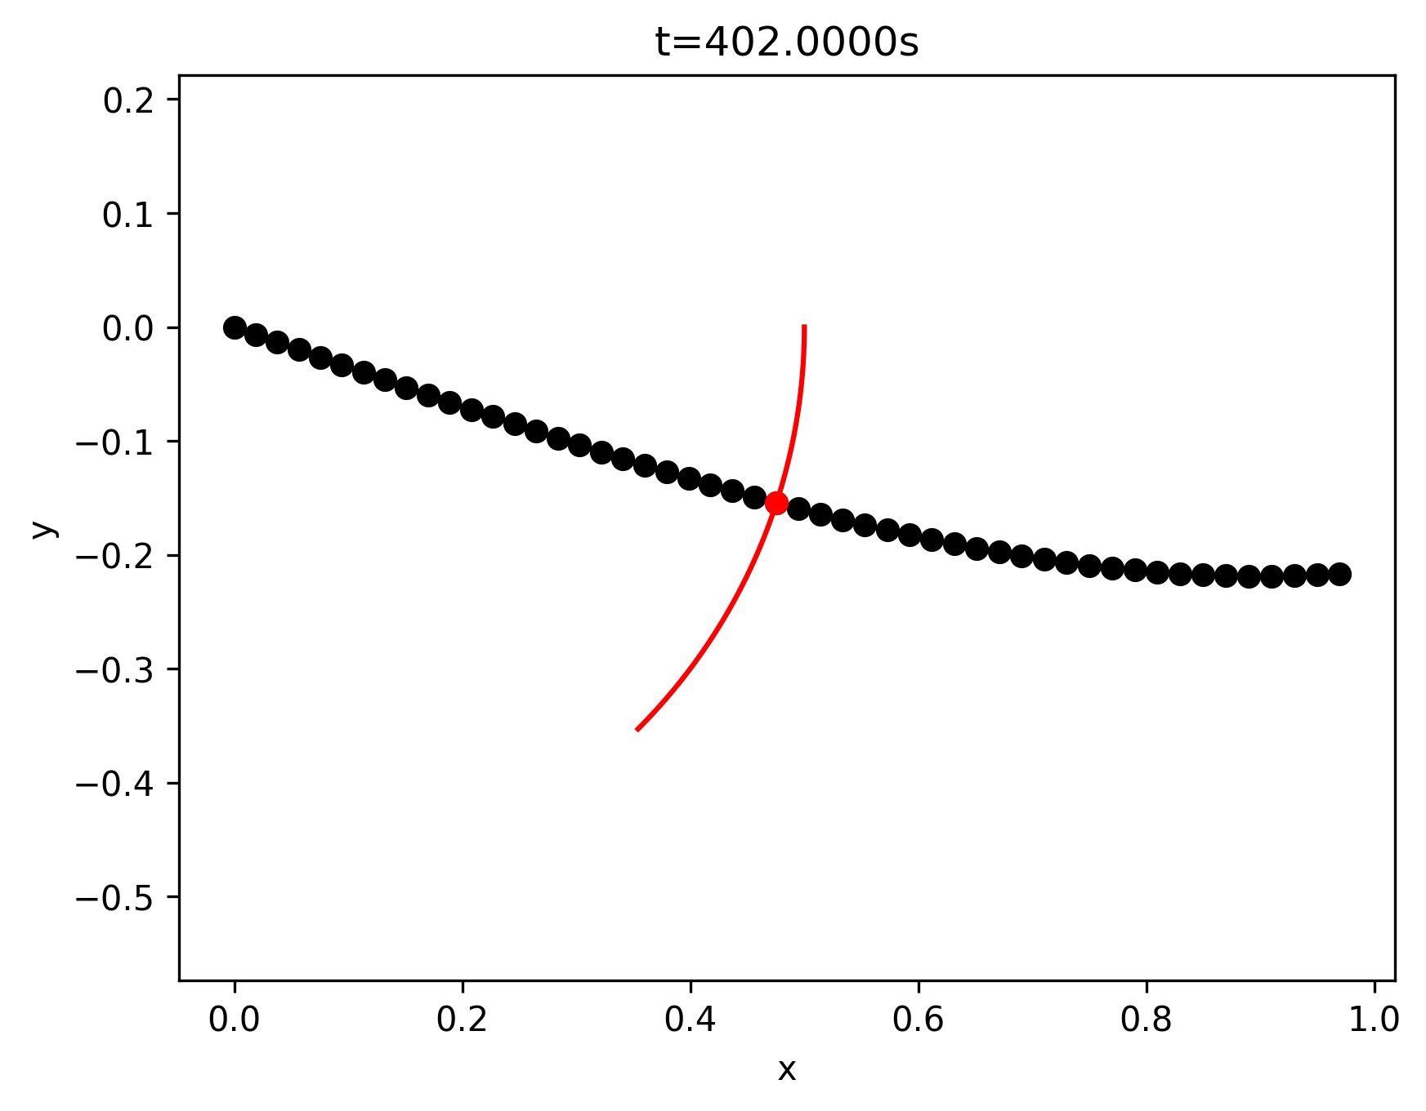
Figure 6. Beam at 402 sec

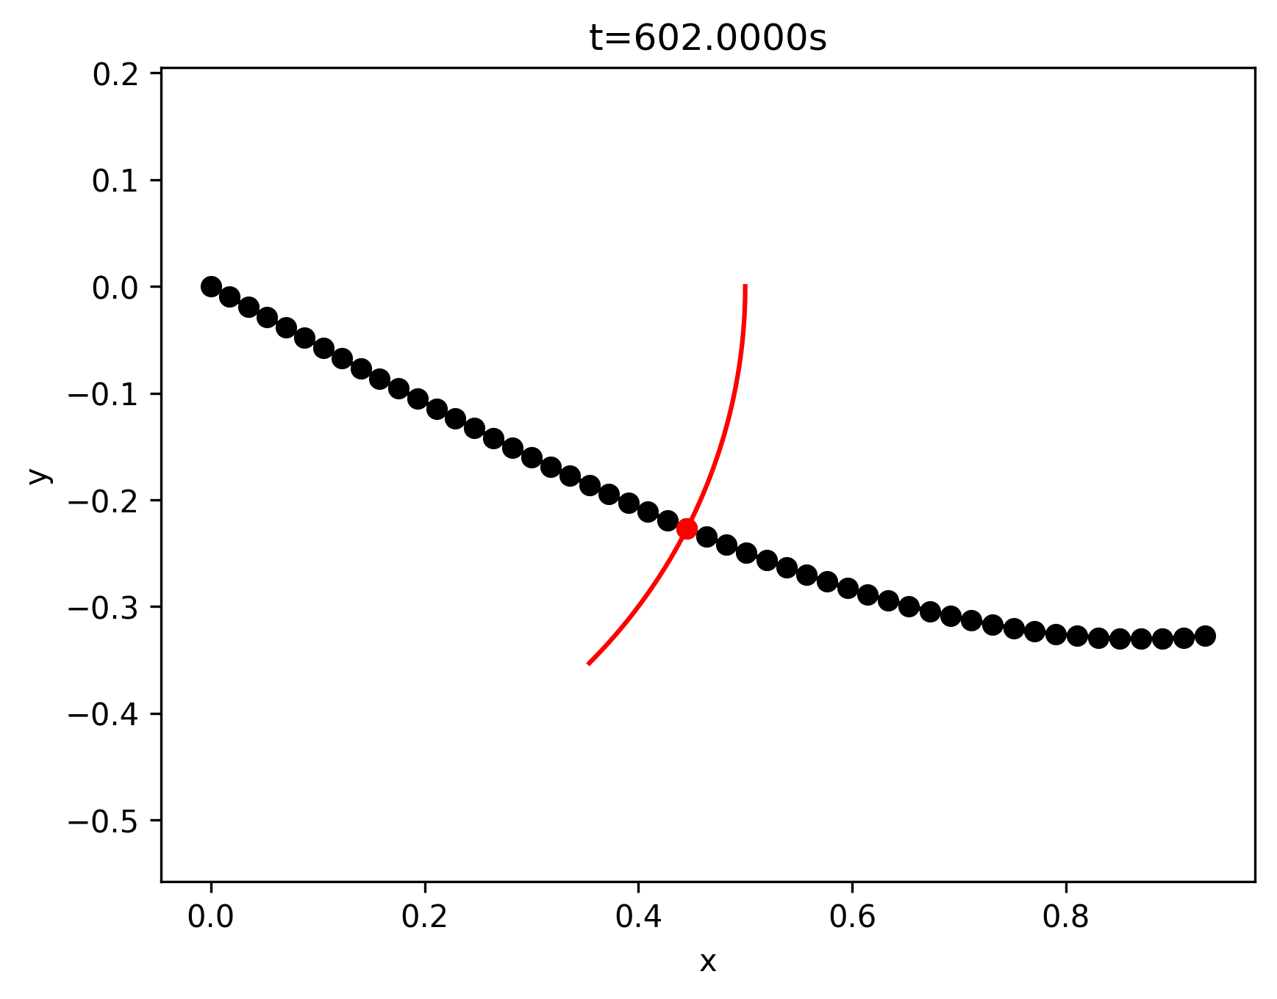
Figure 7. Beam at 602 sec

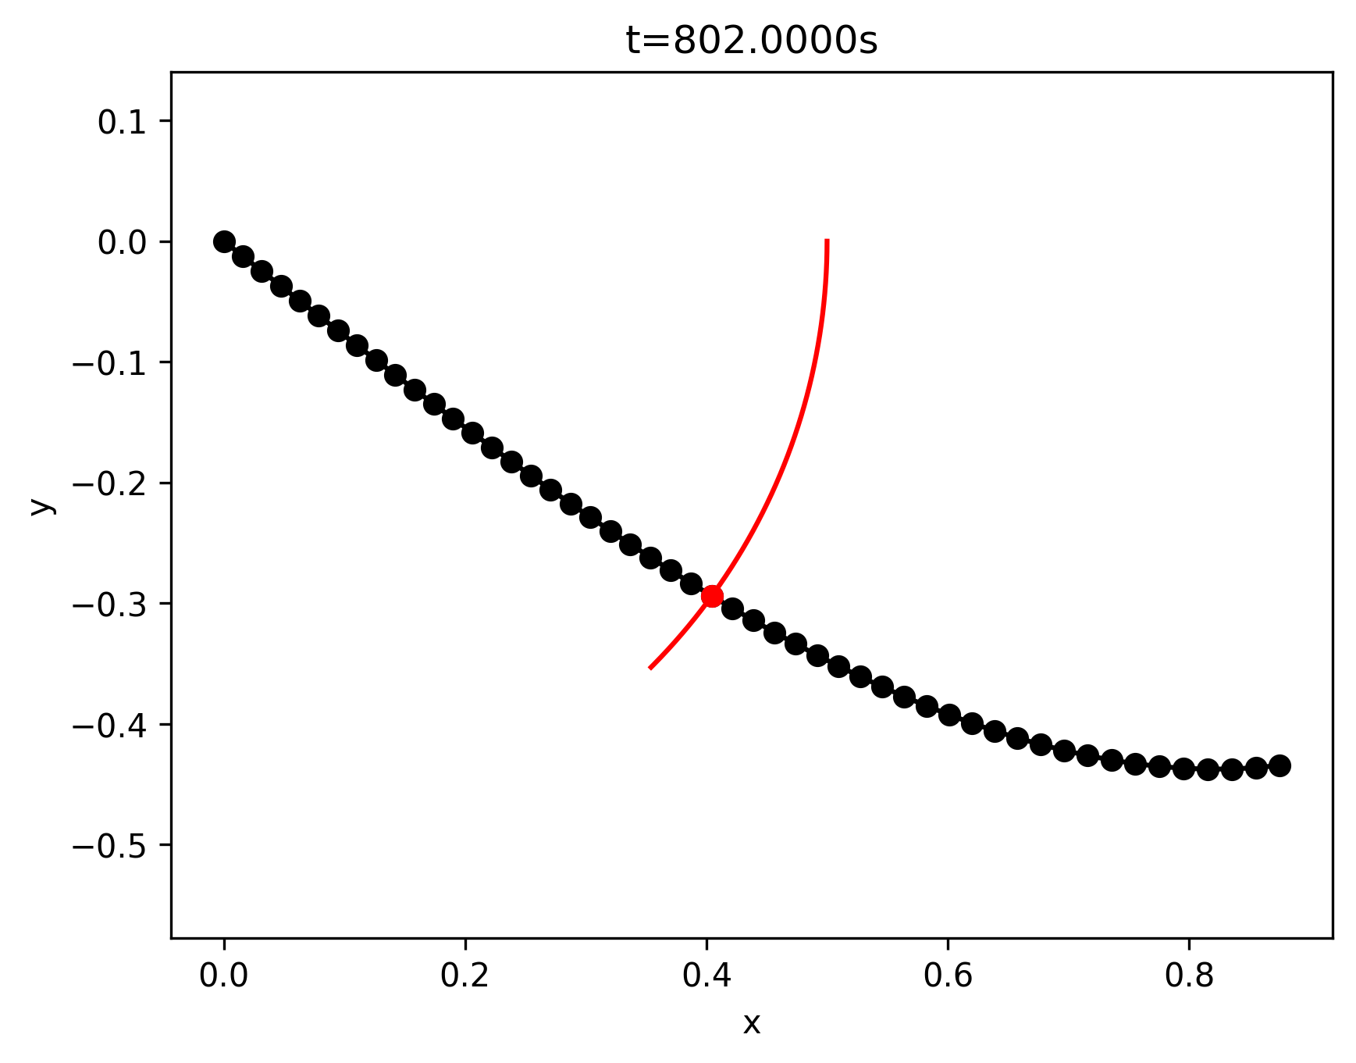
Figure 8. Beam at 802 sec

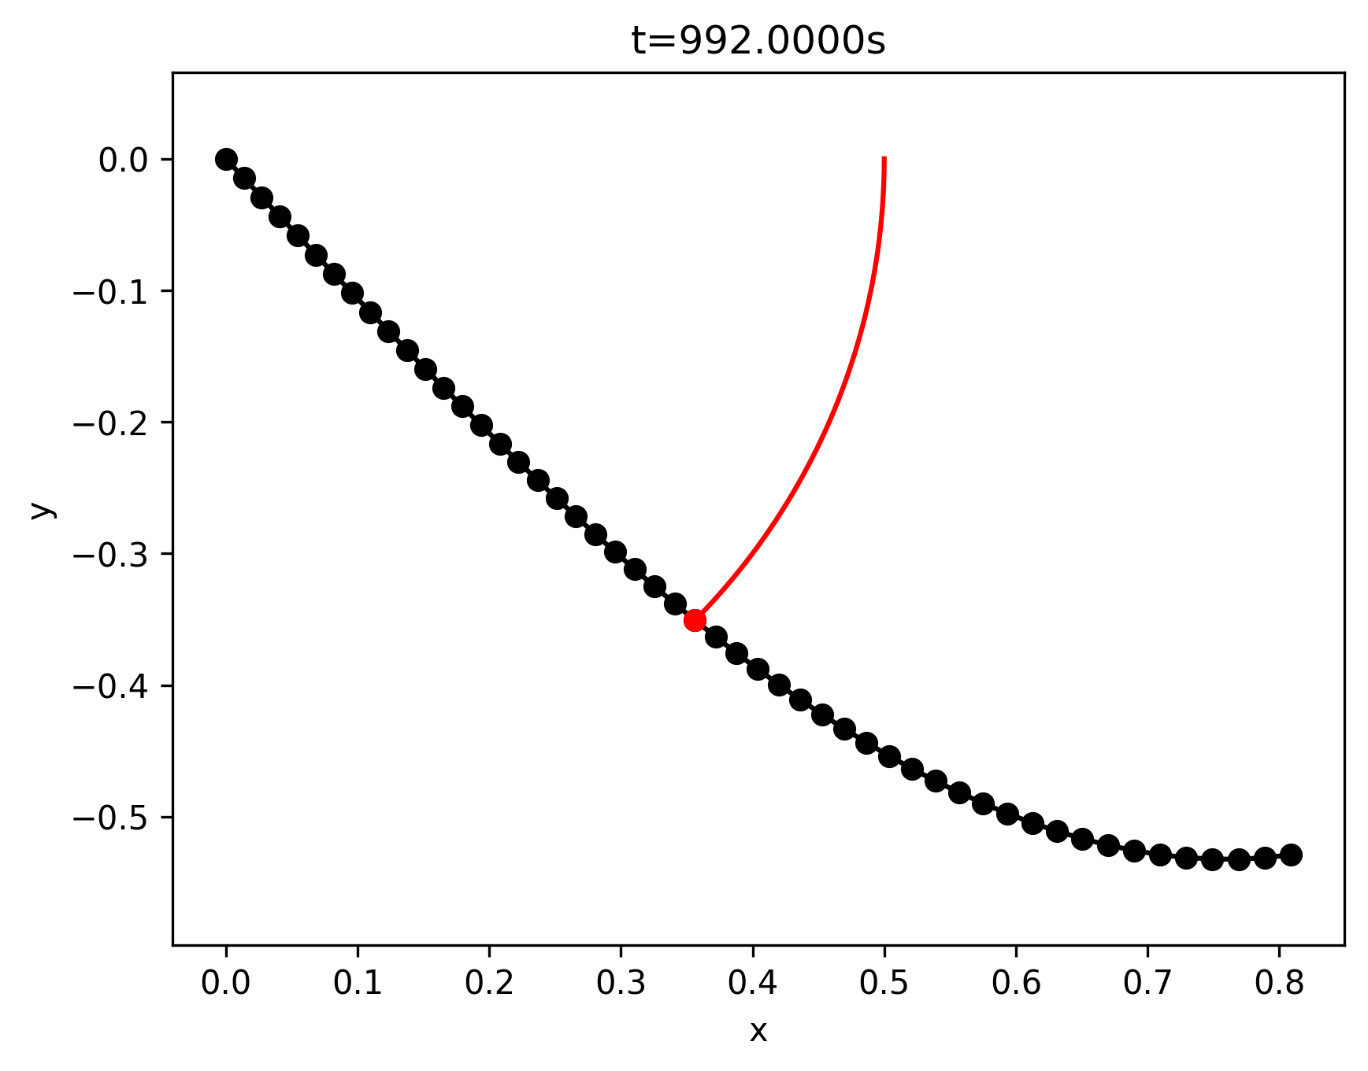
Figure 9. Beam at 992 sec

Task 4: Discussion of Feasibility Limits:
The code uses a saturation limit to contain the actuators outputs to reasonable range. X is constrained to between 0m and 2m, Y between -1m, and 1m, and Θ between π/2 and – π/2. This potentially could create some skipping issues. However, the beam begins in a neutral positon, and the Moore Penrose Pseudoinverse calculates a minimum displacement solution for the Dirichlet constraints. This means that for the relatively small trajectory we are tasked with following, the saturation limits are not closely approached.

- “25F-MECH&AE-263F-LEC-1 Mechanics of Flexible Structures and Soft Robots,” M. Khalid Jawed [Online]. Available: https://bruinlearn.ucla.edu/courses/216502.

- “The Moore-Penrose Pseudoinverse (Math 33A: Laub).” Available: https://www.math.ucla.edu/~laub/33a.2.12s/mppseudoinverse.pdf

